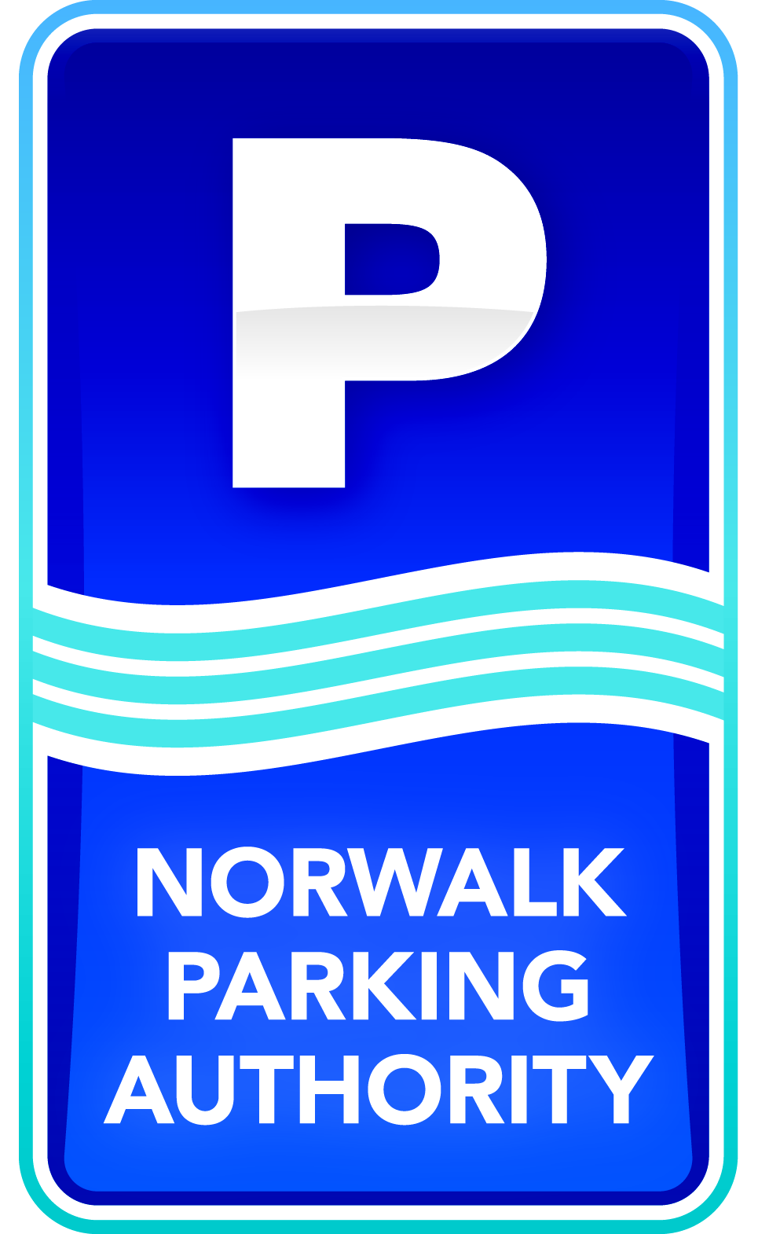
Contact: Carolyn Ripp. (203) 852-1261, ext. 107

Norwalk Parking Authority Opens Facilities for Parkers During Street Sweeping

Norwalk, CT (April 9, 2015) - - Don’t get caught getting towed during street sweeping! To help Norwalk motorists, the Norwalk Parking Authority announced today that as part of the resumption of street sweeping initiated by Norwalk Mayor Harry Rilling, it will open its facilities free of charge for overnight parkers in the South Norwalk and Wall Street areas. From Sunday night at 10:00 p.m. until Monday at 8:00 a.m. people will be able to park their cars for free in the Yankee Doodle Garage in the Wall Street area and in the Webster lot in SoNo in order to keep the streets clear for sweeping.
Street sweeping by the Norwalk Department of Public Works resumed on April 6 and will continue every Monday from 3:00 a.m. - 8:00 a.m. until November. Sweeping areas include Wall, Main, River, Isaacs, Burnell Boulevard and Belden Avenue in the Wall Street area, and Washington, Water, Ann, Marshall and North and South Main in SoNo,
“We are happy to help the city and its residents, keeping our downtown areas clean so they are nice areas to live, work and visit, and making it hassle-free for parkers,” says Parking Authority Chairman Julius Hayward.
The Norwalk Parking Authority is a financially self-sustaining organization responsible for the operation and maintenance of the municipal parking system in Norwalk. It is not financed by taxpayer dollars. The Authority is committed to making Norwalk a better place to live, work and visit by collaborating with community organizations while providing exceptional customer service to parking customers. The Norwalk Parking Authority can be reached at (203) 831-9063 or at: www.norwalkpark.org.

# # #

